**TITLE**

**Setup and Use a Firewall on Windows**

**Objective**

Configure and test basic firewall rules to allow or block traffic on a Windows machine.

**Step-by-Step Implementation:**

**Step 1: Open Windows Firewall**

1. Press Windows + S and type **"Windows Defender Firewall"**.
2. Click on **"Windows Defender Firewall"**.
3. On the left side, click **"Advanced settings"** to open the firewall with advanced options.

**Step 2: View Current Firewall Rules**

* In the **Windows Defender Firewall with Advanced Security** window, you'll see:
  + **Inbound Rules**
  + **Outbound Rules**
  + **Connection Security Rules**

**Step 3: Block Inbound Traffic on Port 23 (Telnet)**

1. Click on **"Inbound Rules"**.
2. Click **"New Rule…"** (right panel).
3. Select **Port** → Next.
4. Choose **TCP** and enter **23** in "Specific local ports" → Next.
5. Choose **Block the connection** → Next.
6. Apply to **Domain, Private, Public** → Next.
7. Name the rule (e.g., "Block Telnet Port 23") → Finish.

**Step 4: Test the Rule Using PowerShell**

1. Open **PowerShell** as Administrator.
2. Run the following command:

Test-Net Connection -Computer Name localhost -Port 23

1. Observe the output:
   * If you see TCP Test Succeeded: False, it means the port is successfully blocked.

**Step 5: Remove the Rule (Optional)**

* To remove the block:
  1. Go to **Inbound Rules**.
  2. Find the rule named "Block Telnet Port 23".
  3. Right-click → **Delete**.

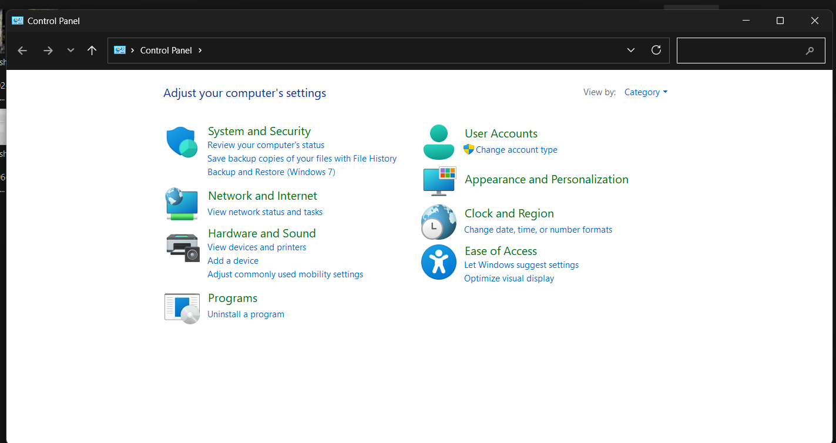

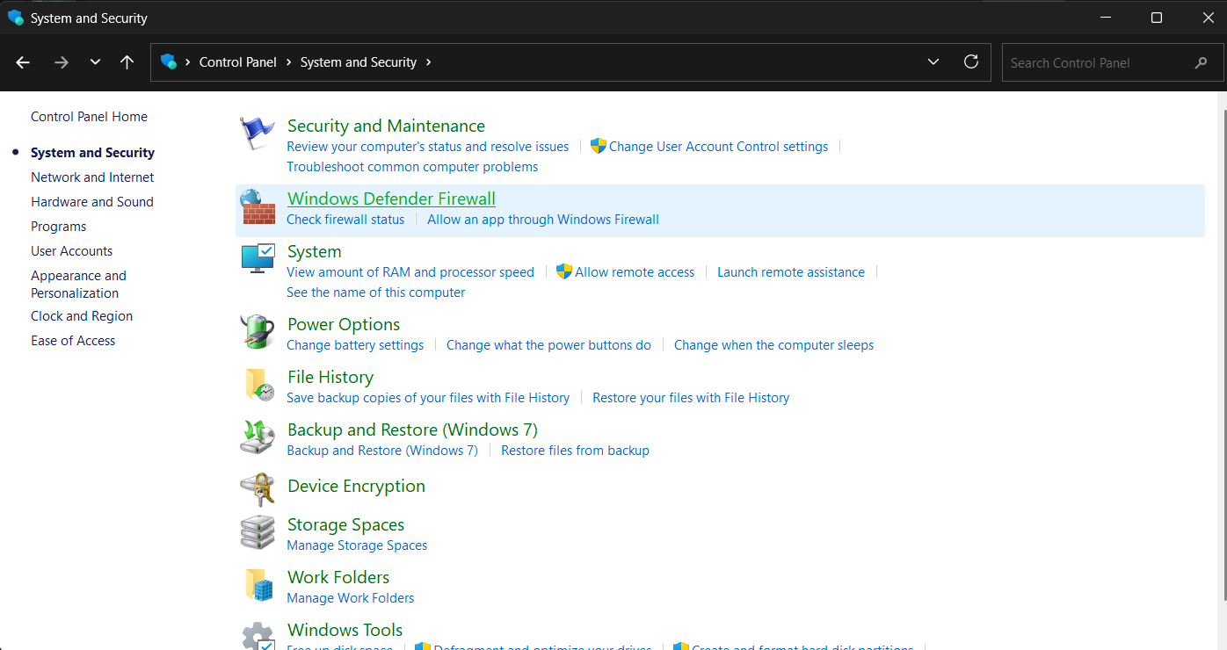

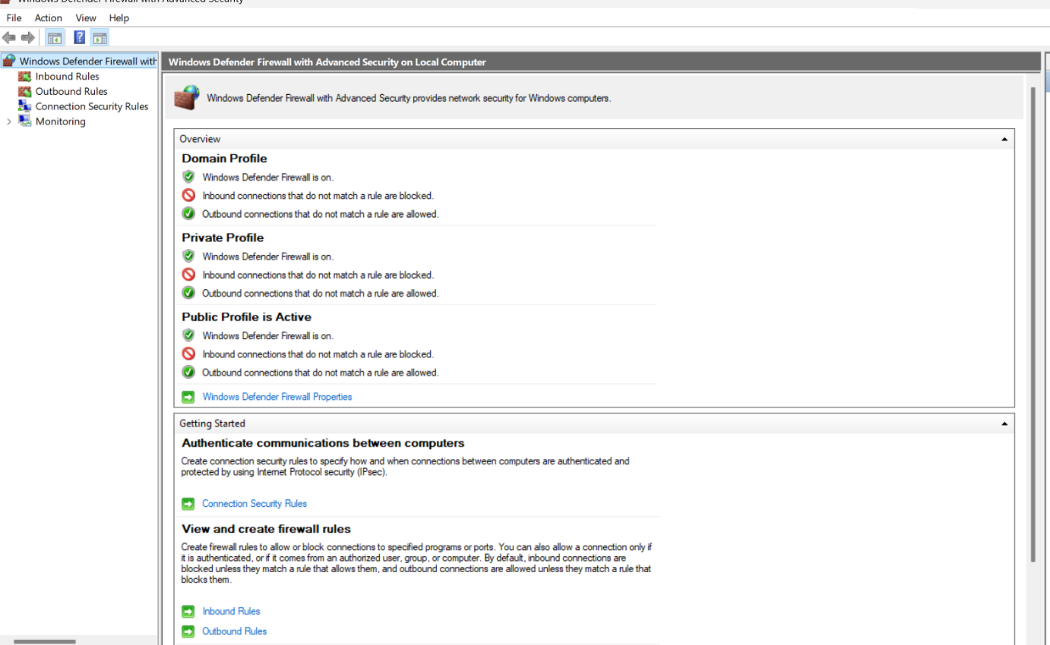

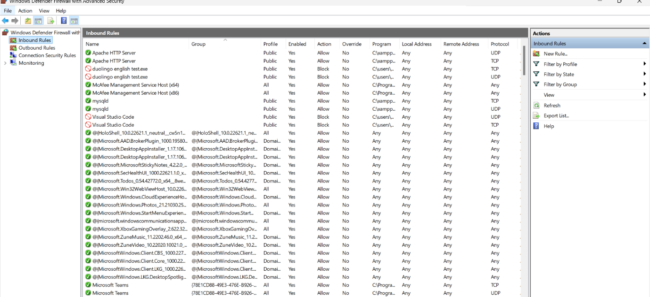

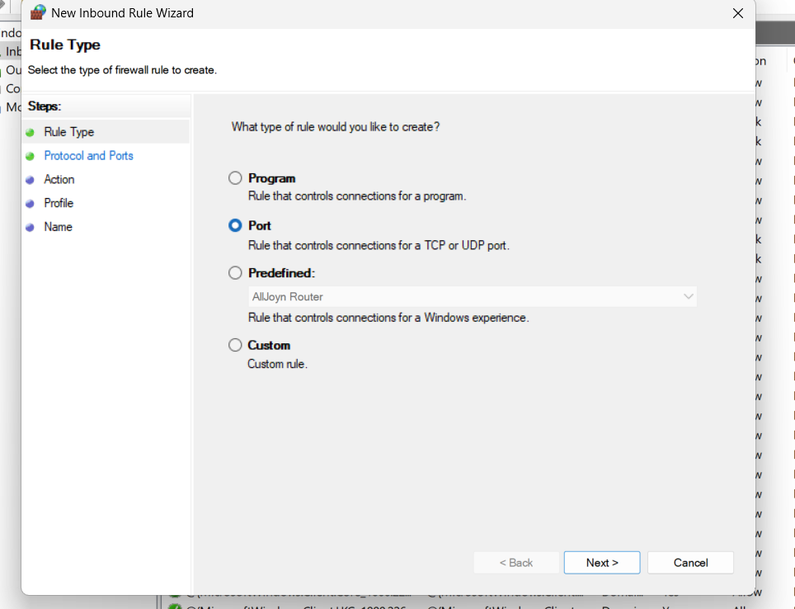

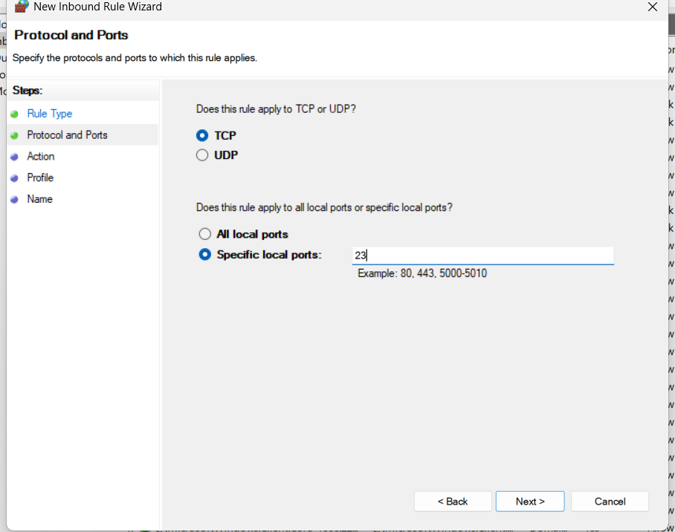

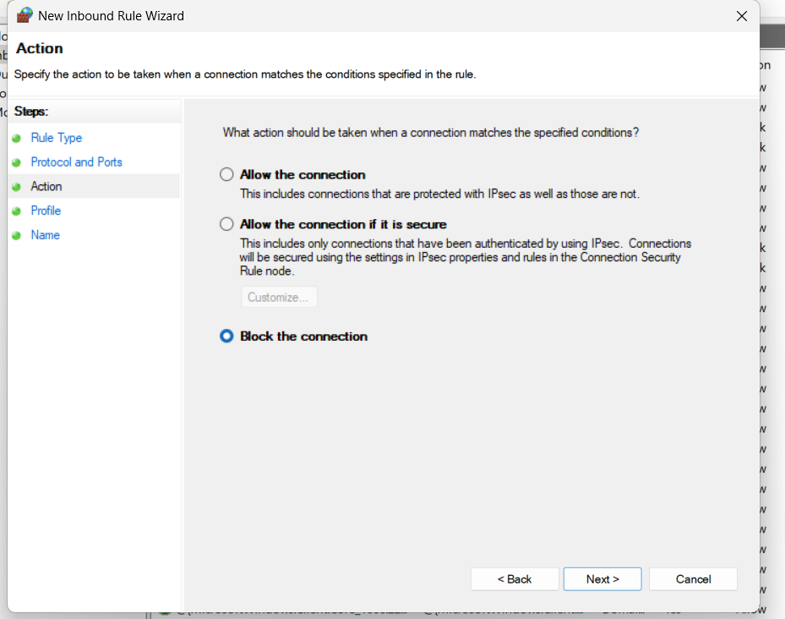

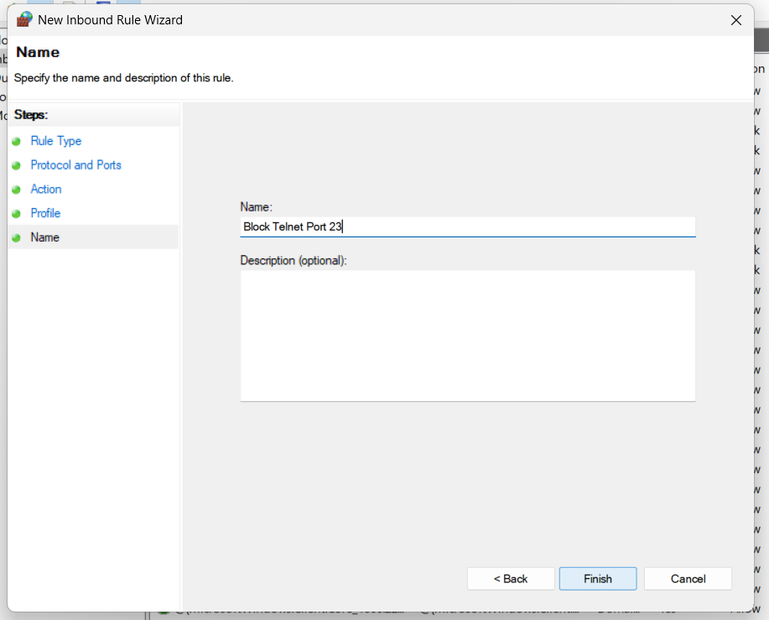

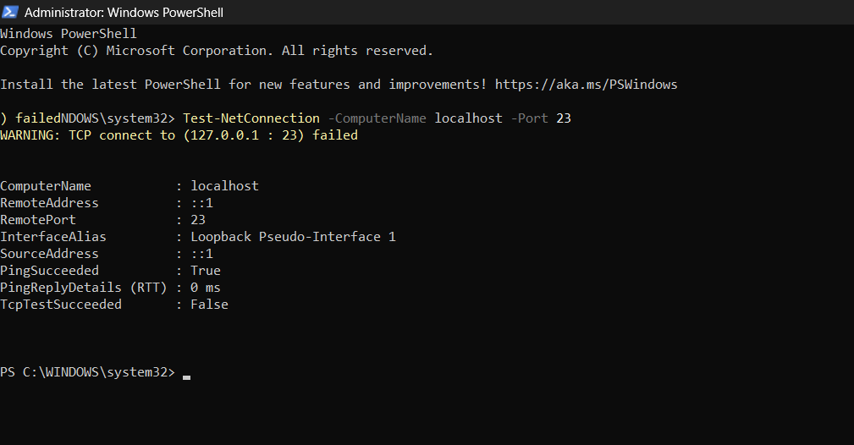

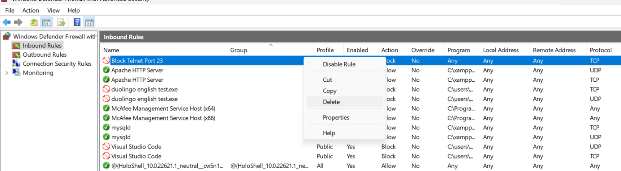

**Conclusion**

This task demonstrated how to effectively configure firewall rules in Windows to block specific network ports, such as Telnet's port 23. You learned how to test the rule using PowerShell and understood how firewalls help control traffic based on defined criteria. Implementing such rules enhances the security posture of your system by reducing its exposure to unwanted or vulnerable services.